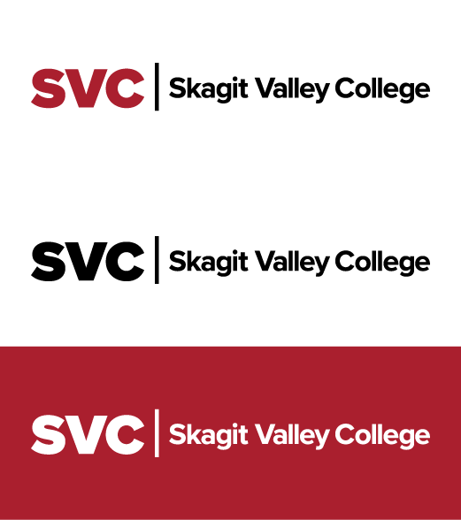

Prior Approval for Purchase of

Light Refreshments or Meals with Meetings

|  |  |
| --- | --- |
| Purpose of meeting, event, or  formal training session: |  |
|  | |
| Date & Time of event: |  |
|  | |
| Location: |  |
|  | |
| Number and type of participants include:  *(i.e. vocational directors, council members, staff, etc)* |  |
|  | |
| Meals/light refreshments will be an integral part of the meeting or training session:  Yes  No | |
|  | |
| Regulations regarding use of state funds for food purchases can be found in 70.10.10 – 70.10.40 of OFM’s SAAM. The cost of meals must be within the limits published in 10.90.20 of OFM’s SAAM. | |
|  | |
| Meal Furnished:  *(Only one per meeting session.)* | ($5) Refreshments  ($17) Breakfast  ($20) Lunch  ($31) Dinner |
|  | |
| Check one:  A sign-in sheet verifying attendance with be provided upon completion of the event.  This event is open to the entire college campus or to the public and a signature sheet is not required. | |

Signature of Requester Date

____________________________________

Printed Name of Requester

Sabrina Houck, Business Services Director Date

*(Designated approval authority by President)*