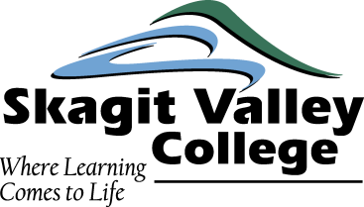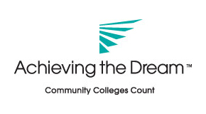

Achieving the Dream Research Projects
Dec 2011 – Feb 2012

- An examination of the success rates for on-ground and online delivery of developmental and college-level Math and English classes and related prerequisites. Abel Gage, Trish Barnes, Hilda Halliday, and Catherine Wessels.
- An analysis of the impact of College Success Skills classes on success rates if taken prior to or concurrent with pre-college Math & English. Gail Bruce, Linda Moore, and Maureen Pettitt.
- An examination of when students leave SVC and why. Les Stanwood, Trish Barnes, Mary Alice Grobins, and Cliff Palmer.
- A study of the pass rates for gatekeeper courses disaggregated by student intent. Laura Cailloux and Maureen Pettitt.
- An analysis of the impact of when a student takes their first math class (is there data that indicates that students should take their first Math class soon after entering, or later after they have had success in other classes?). Hilda Halliday, Dan Graber, Bob Malphrus, and Matt Scammell.
- An examination of the importance of a student earning a B or better in a class and passing the next class: Abel Gage and Cliff Palmer;
- A study of the potential relationship between degree complexity and completion rate: Sally Dixon; Jeff Stady; Ann Zukoski; and Dave Paul.
- A study that develops a profile of success (why do some students stay to complete a degree or certificate?): Joan Youngquist; Scott Hall; Kathy Shannon; and Tom Tomeoka.
- An examination of transcripts to examining the characteristics of students who leave with no achievement points after a few quarters compared to students who do earn points: Maureen Pettitt and Les Stanwood.
- An analysis of success rates for student of color: Laura Cailloux and Gail Bruce
- An examination of the process for students from first contact with college through their first quarter: Joan Youngquist and Dave Paul

