Student Achievement Points, 2010-11

Board Ends Policy/Core Themes

Ends Policy E-6/Core Theme III: Creating and Supporting Educational Alignment, Achievement and Transitions

Objective #2: Student progression and completions

November 8, 2011

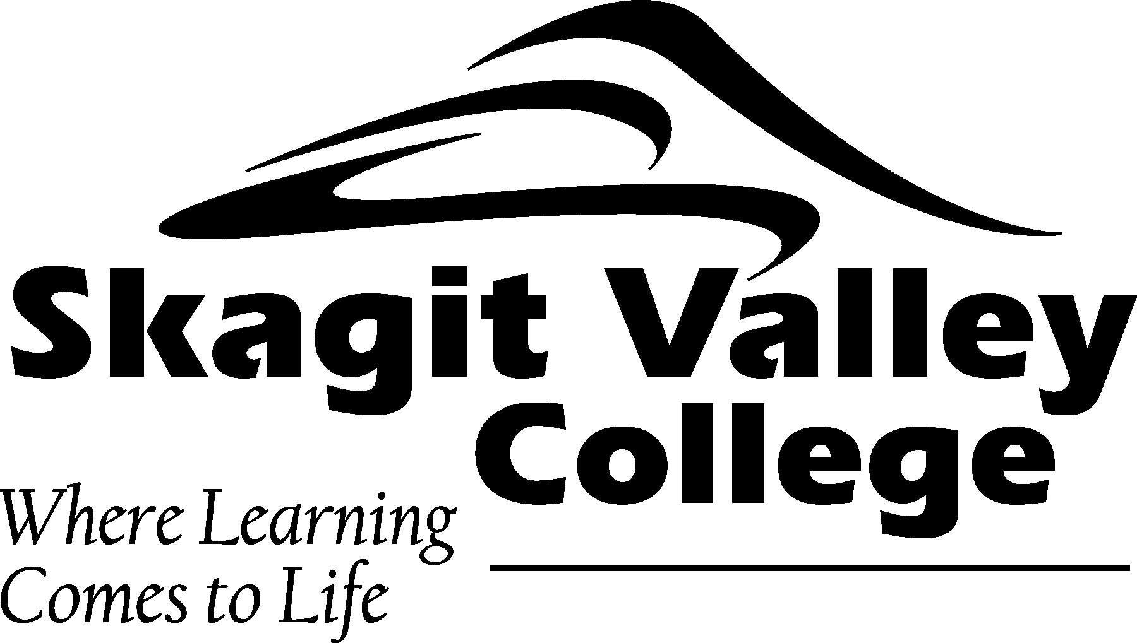

Background – The Student Achievement Initiative
The SBCTC has designed an accountability system based on student achievement points. The student achievement database enables colleges to track students and identify the incremental successes achieved during the year in the following categories:
- gains made in basic skills courses,
- completing a pre-college math or English course (college ready),
- earning first 15 college-level credits,
- earning first 30 college-level credits,
- earning first 5 credits in college-level math, and
- earning a certificate, degree or apprenticeship award.

The system identifies these as “momentum points” because they add momentum to a student’s longer term success. The opportunity for earning points is greatest for students in basic skills, who earn points each time they successfully move up a level. Students also earn points each time they successfully pass a developmental course. Students can only earn a point once for each of the other categories.

These measures were designed to focus on short-term, intermediate outcomes that provide meaningful momentum towards degree and certificate completion for all students regardless of where they start. The achievement points are also meant to encompass all students regardless of demographic characteristics (race, age, income, employment status), academic program or entering skill levels (basic skills, remedial, workforce education, academic transfer), enrollment (part-time or full-time enrollment), and type of institution attended (urban, rural, large, small, community college, technical college).

In the first round of award payments, colleges received money from the SBCTC (combined with grant funds from foundations) based on the gains made during the two years between 2006-07 (the baseline year) and 2008-09. In October 2010, colleges were awarded student achievement dollars based on the point increase between the 2008-09 and 2009-10 academic years. In October 2011, the colleges were awarded dollars based on the increase between 2009-10 and 2010-11.

In the 2010-11 academic year, Skagit Valley College had the second highest number of student achievement points earned over the prior year in the Washington community and technical college system.

This report is divided into the following sections to provide an overview of SVC student achievement points for 2010-11:
- SVC Overall Performance: 2006-07 to 2010-11
- Points Increase by Category: 2006-07 to 2010-11
- Points Earned by Students in Targeted Programs: 2010-11
The final section documents some of the strategies the college has been implementing to encourage this increase in student achievement.
- SVC Overall Performance: 2006-07 to 2010-11

- The college has consistently increased the total achievement points of students between 2006-07 and 2010-11.
- SVC students earned 10,707 total points in 2010-11, an increase of 1,150 points from 2009-2010.
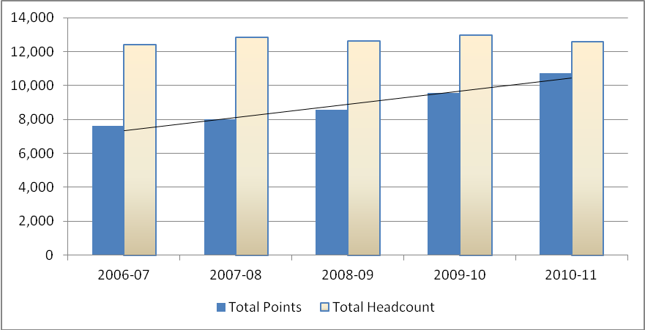

- Because this increase is considerably higher than the modest increases in enrollments during this time period, the points per student—one measure of efficiency—has increased from .62 to .85 points per student.
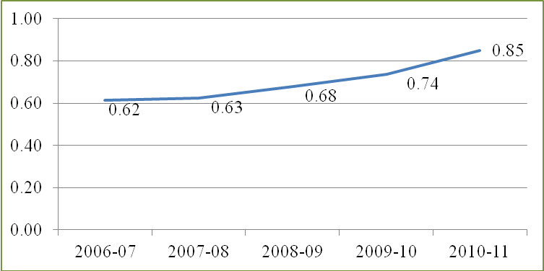

- Points Increase by Category: 2006-07 to 2010-11

- Overall, the point increase from 2006-07 to 2010-11 (3,076) is significantly greater than the modest increases in enrollments (196).

 | Total Points | Total Headcount | Pts/Student
2006-07 | 7,631 | 12,404 | 0.62
2010-11 | 10,707 | 12,600 | 0.85
Increase 2006-07 to 2010-11 | 3,076 | 196

- Increases in points between 2006-07 and 2010-11 were made in all achievement categories.

 | Basic Skills | College Readiness | 1st 15 Credits | 1st 30 Credits | Quantitative/ Computation | Certificate, Degree, Apprenticeships | Total Points
2006-07 | 1,119 | 2,391 | 1,611 | 1,137 | 778 | 595 | 7,631
2007-08 | 1,464 | 2,294 | 1,619 | 1,230 | 773 | 641 | 8,021
2008-09 | 1,749 | 2,403 | 1,699 | 1,294 | 859 | 554 | 8,558
2009-10 | 1,508 | 2,914 | 1,994 | 1,498 | 1,028 | 615 | 9,557
2010-11 | 1,985 | 3,272 | 2,044 | 1,492 | 1,177 | 737 | 10,707

- Points Earned by Students in Targeted Programs: 2010-11

- Basic Skills students enrolled in at least one I-BEST course earned substantially more college-level achievement points than those who did not (note: these are highest point earned, not all points earned).

 | I-BEST Students (N=190) |  | Basic Skills (not I-BEST) (N=879)
 | Count | Percent | Count | Percent
No Momentum | 53 | 28% | 543 | 62%
Basic Skills Points | 43 | 23% | 248 | 28%
Pre-College Courses | 14 | 7% | 17 | 2%
15 CLVL Credits | 21 | 11% | 33 | 4%
30 CLVL Credits | 20 | 11% | 20 | 2%
Quant Course | 20 | 11% | 14 | 2%
Tipping Point | 19 | 10% | 4 | 0%
Total | 190 | 100% | 879 | 100%

- Students who obtain state-based financial support are more likely to earn points than students who do not
(note: these are highest point earned, not all points earned).

 | Work  first | Worker Retraining | Pell Grant | Opportunity Grant | State Need Grant | All Others
No Momentum | 66% | 40% | 29% | 35% | 25% | 64%
Basic Skills Points | 11% | 4% | 1% | 12% | 1% | 4%
Pre-College Courses | 8% | 8% | 16% | 10% | 15% | 6%
15 CLVL Credits | 3% | 6% | 12% | 9% | 11% | 7%
30 CLVL Credits | 4% | 13% | 15% | 14% | 19% | 7%
Quant Course | 5% | 14% | 16% | 9% | 17% | 7%
Tipping Point | 3% | 14% | 10% | 10% | 12% | 5%
Total | 100% | 100% | 100% | 100% | 100% | 100%
- Strategies Implemented to Increase Points Earned by Students

Basic Skills
- Eliminated waiver
- Required ABE orientation classes
- Implemented ABE attendance policy to increase retention
- Piloted a counselor-enhanced ABE class
- Increased ESL Tutoring at both MV and WIC

I-BEST
- Employed PTSS Case Management
- Embedded College Success Skills course in a free pre-I-BEST “Workplace Essentials” course
- Implemented mandatory orientation & Testing
- Initiated ABE/ESL support classes
- Increased I-BEST capacity using Worker Retraining funding

Academics
- Increased Counselor-Enhanced Developmental Learning Communities
- Piloted of ALEKS web-based curriculum for self-paced Math 96
- Piloted math project with Anacortes High School
- Linked College Success Skills with survey classes in Science, History, and Psychology
- Widespread implementation of student centered teaching strategies (AVID, Inquiry, Teaching for Understanding, etc)

Student Services
- Implemented evening bilingual registration at MV
- Coordinated with Math Center to reduce number of incompletes
- Increased contact with students on Academic Alert and Probation
- Increased tutoring hours at WIC
- Increased tutoring assistance with TRiO

Information Technology (in progress)
- Automate mandatory advising
- Implement Academic early warning
- Create advisor data portal
- Implement degree estimator tool

